Hillbilly Elegy  - Jackson Webb, Josh O’Donovan, Sue Conley  Borrowed from Waterstones  What is an elegy?  An elegy is a poem or story that expresses sorrow for the dead. 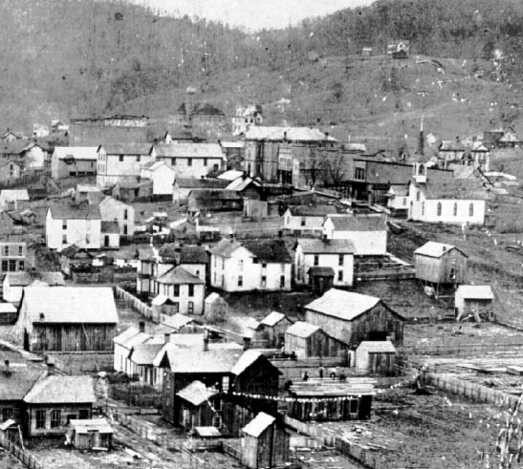  Borrowed from Kentucky Coal Education | Why did J.D. Vance refer to his book as an “elegy”?  On page 145 Vance explains “Our elegy is a sociological one, yes, but it is also about psychology and community and culture and faith.” In this case, Vance writes an elegy on the death of many hillbilly values and the overall decline of the white middle class. Due to the decrease in jobs, and the increase in opioid abuse the reader is shown the worst of the death of a culture.  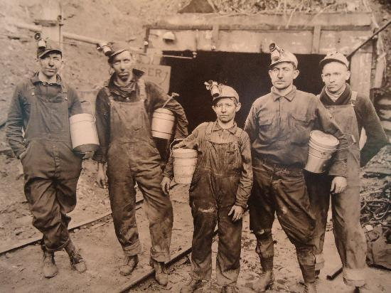  Borrowed from Kentucky Coal Mining Museum  What caused the death of this class?  During the 1950s, many people left the hills of Appalachia in search of steady jobs. Many ended up like Vance’s family, with steady jobs in the manufacturing industry. However, at this time the hillbillies had not lost their values, while in the public eye they were regular middle-class Americans, behind closed doors they were still the same hillbillies they had always been. But as Vance describes on page 7, “…manufacturing jobs have gone overseas and middle-class jobs are harder to come by for people without college degrees.” The offshoring of these middle-class jobs caused the bubble of security that hillbilly transplants enjoyed to burst, exposing the flaws of their society. | Borrowed from MiddletownUSA  How did J.D. not go through this?  One of the main vehicles of Vance’s theme of change is his grandmother, whom he calls Mamaw. Mamaw was a woman from the sticks of Kentucky, and once the hillbilly exodus started she moved with her husband to Middletown, Ohio. In Middletown her husband found a job at the Armco steel plant, and they began their comfortable middle-class lives, while still holding on to their hillbilly roots. When the jobs left America, many people thought that there was no chance to advance in society, and that became true because they began to believe that the cards were truly stacked against them. However, Mamaw did not feel that way and she instilled that value in Vance, which eventually helped him achieve what he has in life.  Borrowed from Ohio Women’s History  What is the tone throughout the book?  The memoir Hillbilly Elegy, as the title suggests, has a very somber tone as it laments the dying culture of this particular group of poor white Americans. The author, J.D. Vance, overwhelms readers with the self-destructiveness of Hillbilly culture and their lack of motivation to adapt to the 21st century. With the disappearance of a multitude of factory jobs. For example, Vance describes one able-bodied friend, a lifetime welfare recipient, as someone who quits his job because he is “sick of waking up early,” and takes to facebook to blame his
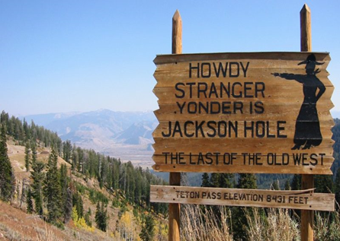
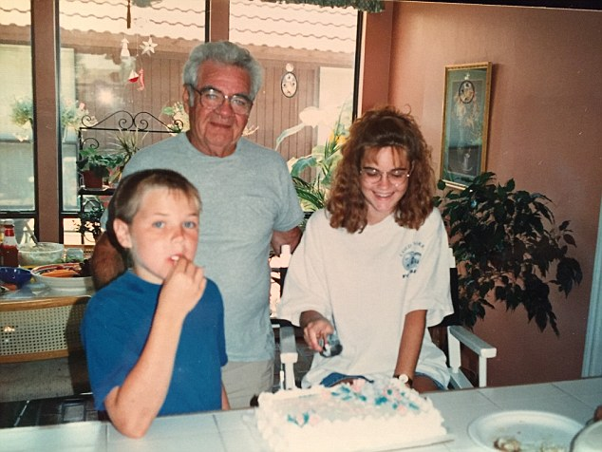
Borrowed from
unemployment on the “Obama economy.” The economic problems shared by many hillbillies cause numerous town stores to go out of business due to the lack of support, giving the towns a gloomy feel as seen in the juxtaposed image.
Borrowed from World Socialist Web Site
What devices were used?
Vance reflects on his memories of family members to present the dichotomous traits present in hillbilly culture. For instance, he conveys his Mamaw’s personality through contrasting rhetoric, capturing both sides of her personality. On one hand, Mamaw prioritizes loyalty over everything, saying “There is nothing lower than the poor stealing from the poor. It's hard enough as it is.” However, in contrast, Vance exposes his Mamaw’s vulgar and aggressive sides, even describing how she attempted to light her husband on fire and kill him after he had come home drunk one too many times. Likewise, Vance also discusses his Papaw’s mixed qualities. Initially, Papaw was an abusive alcoholic to the point that Mamaw was forced to separate from him. However, once becoming sober, Papaw was a model grandparent, with Vance saying “Papaw believed that hard work mattered more. He knew that life was a struggle, and though the odds were a bit longer for people like [us], that fact didn’t excuse failure.” In this way, Vance juxtaposes the very best and worst of hillbilly culture.

Many book reviews have stated that the credibility of Vance increases the believability of many of his claims. One controversial topic he has especially spoken out on is the 2016 election. For example, New York Times book reviewer, Jennifer Senior, states, “Mr. Vance, offering a compassionate, discerning sociological analysis of the white underclass that has helped drive the politics of rebellion, particularly the ascent of Donald J. Trump. Combining thoughtful inquiry with firsthand experience” Vance’s relatability to the hillbillies gives him an accurate perspective of why they would vote for Trump. Trump claims that he will reimplement steel and coal jobs, sources of labor which drive the hillbilly economy.
Throughout this book, J.D. Vance incorporates ethos to boost his credibility towards the reader. Vance repeatedly refers to his time spent in the hillbilly culture to demonstrate how he has a true understanding of how they live. For example, he states, “my address was where I spent most of my time with my sister and mother, wherever that might be.” by stating that his address changed frequently he is referring to how many people in this culture, including his mother, move constantly when money is low. By saying this, Vance expresses how he has experienced many aspects of this culture first hand, which makes his claims of the culture more believable. He uses ethos again when he states, “my home has never changed: my great grandmother’s house in Jackson, Kentucky.” this represents how he has lived in the heart of the hillbilly culture and has experienced it as a home. By describing how he relates to this place as a home greatly increases the credibility of his claims about this culture.
Vance asserts ethos to support his claims later in the book by demonstrating his experiences in life aside from the hillbilly culture. For example, he says, “for the first time in my life, I felt like an outsider in Middletown.” this demonstrates how after going through the marine corps and Yale Law School, he has succumbed to the life of a successful American. This boosts the credibility of his claims because not only has he experienced major aspects of the hillbilly culture, but also the culture of a successful American. Vance intensifies his level of understanding by demonstrating how he understands both sides of the cultural groups. For example, “As a cultural emigrant from one group to the other, I am acutely aware of their differences.” By demonstrating his understanding of the drastic differences in the cultures, this boosts his credibility towards the reader. Because of his experiences and knowledge of both cultures Vance infectiously persuades the reader that there needs to be a reform in the hillbilly culture.
Borrowed from Daily Mail
The Positive Light of the Book.
One of the lone sources of positivity in the memoir is Vance’s wife, Usha, who helps to complete his life by erasing his self-doubts about fitting into white collar society. For example, Rothman of the New Yorker magazine says, “Usha understands his feelings of dislocation, which makes sense: Vance’s story is, in many respects, an immigrant story.” Being that Vance has transcended from hillbilly culture to the rising elite of America, there are many aspects of everyday life he is unfamiliar with. For instance, when he goes to a recruiting dinner while at Yale, he is forced to call Usha for advice, saying “What do I do with these [9] damned forks? I don’t want to make a fool out of myself.” Usha’s advice regarding when to use each utensil both comforts Vance and allows him to ace the interview, arming him with the tools to succeed in future white-collar scenarios.
Borrowed from NBC News

