M e a n i n g O f T h e T i t l e
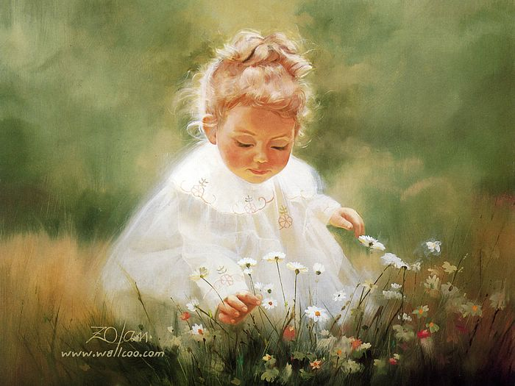
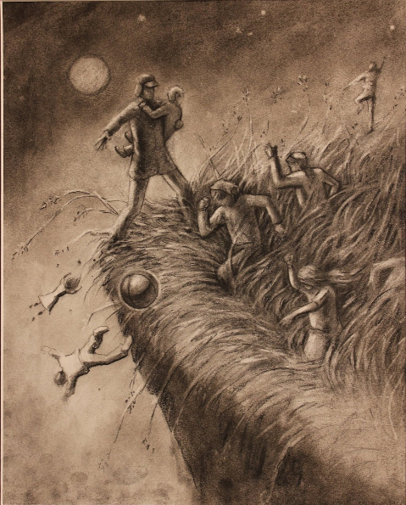
The title of Catcher in the Rye reinforces the idea of childhood innocence. The phrase “catcher in the rye” is based off of a song called “Comin’ thro’ the rye” which is about losing childhood innocence. In the book Holden tells his little sister Phoebe that he wants to “catch children in the rye” meaning that he wants to save children from losing their childhood innocence. He wants to protect children from this fate because he lost his innocence so young and because he knows how hard it is to enter the adult world. Holden wants to control something that he has no control over. He lost his childhood innocence when his little brother died and as a teenager this makes him irritable, crude and almost bi-polar as he navigates his teen years. By: Haley McDonald

T h e m e s
Growing up feeling victimized by the world, Holden exerts his deeply rooted loneliness, hatred of adulthood, and self-protection to mask the underlying factor of denial. Loneliness is the driving force of understanding Holden's quest for companionship. His longing for a meaningful connection with Jane Gallagher is evident through repetition of useless relationships that end quickly, strengthening the notion that Holden never truly felt a sense of belonging. His fear of death, intimacy, and the complications that come with adulthood, results in his need to preserve the innocence of childhood. Throughout the novel, the phoniness and fakeness of adulthood is referred to using “whatever” kind of language. He ultimately aims to protect himself and other children from these fears. Dramatic irony is linked through each theme because the reader understands Holden’s true insecurities despite his disregarding tone. By: Ashley McCauley
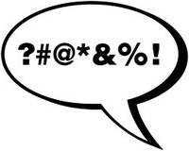
U s e o f D i a l o g u e
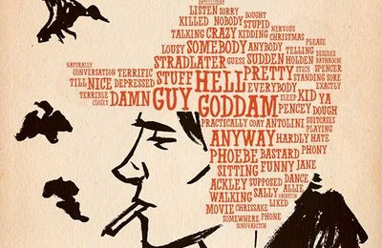
In the Catcher in the Rye, Salinger amplifies the dialogue in his writing to strengthen his novel. Some of the dialogue recycled throughout the novel consist of colloquialism, slang, sarcasm, and swear words. Due to the abundance of dialogue reworked throughout the novel, Salinger was able to portray the teenage mind of Holden by utilizing these words to make certain points in conversations, shape the language, sketch mindset in which teenagers have, and mimic how teenagers are scared to grow up. An example of the dialogue he replicates shines through on page 3 “I’m not going to just tell you my whole goddam autobiography or anything.” and on page 12 “‘you glanced through it, eh?’ he said --very sarcastically.” By applying dialogue in the Catcher in the Rye, Salinger helps his readers better understand the novel and Holden live a normal life of a teenager and how he does not want to grow up. By: Daniela McDonald
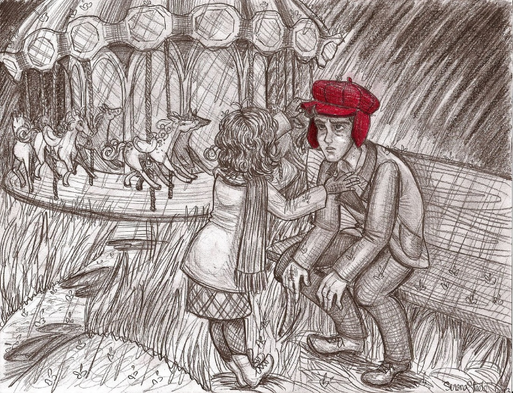

L a n g u a g e a n d P a t t e r n s

In the Catcher in the Rye, Salinger employs informal language and swearing in the service of being true to the nature of a rebellious teen. This idea is further solidified with most characters in the book drinking and smoking, including the underage protagonist. A pattern that Salinger also includes in the novel is the use of italics to emphasize and get the sense of sarcasm that Holden uses across to the reader. In the end of the novel, Salinger abruptly ends the narrative of Holden in a fashion true to that of an impatient teenager. He fails to tell what happens to Holden, and leaves the reader without a real sense of finality. Holden says, “that’s all I’m going to tell about… but I don’t feel like it.” Several reviews claimed they thought the real ending of the book was when Holden took us to where he was watching Phoebe go around the carousel “I was damn near bawling, I felt so damn happy, if you want to know the truth. I don't know why. It was just that she looked so damn nice, the way she kept going around and around, in her blue coat and all. God, I wish you could've been there.” The only trace of true happiness Holden experiences is when he is spending time with his little sister. By: Megan Bryenton
Works Cited
Ahmed, Abdullah. "The Catcher in the Rye Infographic." Login. N.p., n.d. Web.
Aiman.A. "Catcher in the Rye by J.D. Salinger - Review." The Guardian. Guardian News and Media, 21 June 2012. Web.
"Hindustan Times." Http://www.hindustantimes.com/. N.p., n.d. Web.
"Holden Caulfield." Pinterest. N.p., n.d. Web.
"International Milk Genomics Consortium Home Page." International Milk Genomics Consortium. N.p., n.d. Web.
"J.D. Salinger and The Catcher in the Rye: Read TIME's Original Review." Time. Time, n.d. Web.
"MR. KO." MR. KO. N.p., n.d. Web.
The New York Times. The New York Times, n.d. Web.
N.p., n.d. Web.
Salinger, J. D. The Catcher in the Rye. N.p.: Sterling Pub Co, 2014. Print.
Salinger, J.D., Mark Monday, Matt, Shana, Richard, Kathy, Cheyenne, Stephen, J.G. Keely, Madeline, Haleema, Big Red, Melanie, David, Henry Avila, Dan Porter, Lola Reviewer, Lyn, Chris, Nataliya, Afshar, Fernando, Mai Ahmd, Paul Bryant, Ahmad Sharabiani, Licia, Elise (thebookishactress on Wordpress), Samadrita, Jason, Pooja, and Duane. "The Catcher in the Rye." By J.D. Salinger. N.p., n.d. Web.
Salinger, J.D., and Kathy. “Kathy's review of The Catcher in the Rye.” Kathy (The United States)'s review of The Catcher in the Rye, www.goodreads.com/review/show/18654256?book_show_action=true&from_review_page=1. Accessed 2 Oct. 2017.
Shulgina, Eugenia. "Favourite Art." Pinterest. N.p., 08 Feb. 2014. Web.
Taylor, David. "Word Cloud of The Catcher in the Rye." Prooffreader.com. N.p., 09 Sept. 2013. Web.

