Synthesis Seminar Preparation Activity: The Colonial and Revolutionary Periods

Seminar Focus

Through an examination of direct evidence taken from the art and literature of and about both the Colonial and Revolutionary Periods, we will attempt to discover, during our seminar discussion, shared stylistic choices, rhetorical patterns, and common themes that will further illuminate our understanding of these respective periods in literary history.

Sources for Discussion

Part One of the Seminar: Colonial – the excerpt from Rowlandson’s captivity narrative, Stearns’s “Hannah Duston Killing the Indians,” Shakespeare’s The Tempest, and Miller’s The Crucible

Part Two of the Seminar: Revolutionary – Wheatley’s “To His Excellency, General Washington,” Leutze’s “George Washington Crossing the Delaware,” Henry’s “Speech to the Virginia Convention,” and Paine’s “The Crisis, No. 1”

Directions

In preparation for our seminar, you are asked to write as many questions as you possibly can for each of the following discussion categories. The discussion categories are listed in order of importance for each of the literary periods. For each category, try to make your questions numerous and specific, so we might avoid the excessive repetition of ideas during the seminar discussion.

- Type and print your questions on a single sheet of paper. NO STAPLING OR FRONT/BACK.
- Organize and label your questions by period and category then list them by the order of their importance for each category.
- You must write a minimum of THREE Category ONE questions for each period a total of SIX Category ONE questions. The first three Category ONE questions for each period, will be the ones that will receive an evaluative grade. To exceed expectations, write additional questions in the Category TWO or THREE areas.
- You will be scored for the quality, depth, and originality of your questions.
- Print TWO copies of your questions: one to turn in at the beginning of the seminar – the other to use during the seminar discussion. This activity will be a minor grade.

Colonial Period Discussion Categories – For Category ONE always aim for SYNTHESIS when you write questions

- Write at least three questions that seek to generate discussion about important themes and stylistic elements shared by the assigned sources from the Colonial Period. These questions must be specific in wording and in reference to the source from this period.

- Write questions that seek to generate discussion about each artist’s purpose in respect to the rhetorical techniques and stylistic choices that the artist utilizes to achieve his or her goals. Your questions must be specific in wording and in reference to the artist and his or her work.

- Write questions that compare or contrast the protagonists, themes, and symbols from this unit to the protagonists, themes, and symbols from your reading experiences in ninth and/or tenth grade. Avoid questions that focus on your personal reading experiences; these questions and observations, though potentially interesting, are likely to exclude participation for the majority of seminar participants.

Revolutionary Period Discussion Categories

- Write at least three questions that seek to generate discussion about important themes and stylistic elements shared by the assigned sources from the Revolutionary Period. These questions must be specific in wording and in reference to the source from this period.

- Write questions that seek to generate discussion about each artist’s purpose in respect to the rhetorical techniques and stylistic choices that the artist utilizes to achieve his or her goals. Your questions must be specific in wording and in reference to the artist and his or her work.

- Write questions that compare or contrast the protagonists, themes, and symbols from this unit to the protagonists, themes, and symbols from your reading experiences in ninth and/or tenth grade. Avoid questions that focus on your personal reading experiences; these questions and observations, though potentially interesting, are likely to exclude participation for the majority of seminar participants.

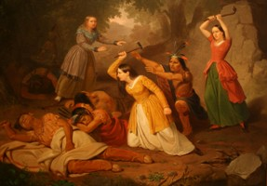

Junius Brutus Stearns, “Hannah Duston Killing the Indians,” 1847. Oil on canvas, 36 1/4 x 42 1/4"

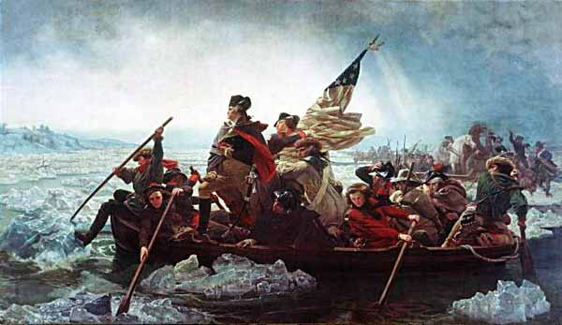

Emanuel Gottlieb Leutze, American, 1816-1868 “George Washington Crossing the Delaware,” 1851 Oil on Canvas; 12 2/5 x 21 1/4 in. (378.5 x 647.7 cm)

