Synthesis Seminar Preparation Activity: The Romantic Period

Seminar Focus
Through an examination of direct evidence taken from the art and literature of and about the Romantic Period, we will attempt to discover, during our seminar discussions, shared stylistic choices, rhetorical patterns, and common themes that will further illuminate our understanding of this period in literary history.

Sources for Discussion
Part One of the Seminar: Romantic Values - “The Tide Rises, the Tide Falls,” “Thanatopsis,” “The Chambered Nautilus,” Cole’s Paintings, and Durand’s Paintings

Part Two of the Seminar: Transcendentalism vs. Anti-Transcendentalism “Civil Disobedience,” “The Divinity School Address,” “Bartleby, the Scrivener,” and “The Minister’s Black Veil”

Directions
In preparation for our seminar, you are asked to write as many questions as you possibly can for each of the parts to our discussion. For each part of the seminar, the discussion categories are listed in order of importance for each of the literary periods. For each category, try to make your questions numerous and specific, so we might avoid the excessive repetition of ideas during the seminar discussion.

- Type and print your questions on a single sheet of paper.
- Organize and label your questions by section of the seminar discussion and by category, then list them by the order of their importance for each category.
- You must write a minimum of three SYNTHESIS questions for each part of the seminar. The first three questions, for each part, will be the ones that will receive an evaluative score.
- You will be scored for the quality, thoughtfulness, and originality of your questions.
- Print two copies of your questions: one to turn in at the beginning of the seminar – the other to use during the seminar discussion. This activity will be a minor grade.

Part I: Romantic Period Discussion Categories – Poetry & Art
- Write at least three questions that seek to generate discussion about important themes and/or stylistic elements shared by the assigned sources from the Romantic Period. These questions must be specific in wording and in reference to the source from this period.
- Write questions that seek to generate discussion about each artist’s purpose in respect to the rhetorical techniques and stylistic choices that the artist utilizes to achieve his or her goals. Your questions must be specific in wording and in reference to the artist and his or her work.
- Write questions that compare or contrast the protagonists, themes, and symbols from this unit to the protagonists, themes, and symbols from your reading experiences in ninth and/or tenth grade. Avoid questions that focus on your personal reading experiences; these questions and observations, though potentially interesting, are likely to exclude participation for the majority of seminar participants.

Part II: Romantic Period Discussion Categories – Transcendentalism & Anti-Transcendentalism
- Write at least three questions that seek to generate discussion about important themes and/or stylistic elements shared by the assigned sources from the Romantic Period. These questions must be specific in wording and in reference to the source from this period.
- Write questions that seek to generate discussion about each artist’s purpose in respect to the rhetorical techniques and stylistic choices that the artist utilizes to achieve his or her goals. Your questions must be specific in wording and in reference to the artist and his or her work.
- Write questions that compare or contrast the protagonists, themes, and symbols from this unit to the protagonists, themes, and symbols from your reading experiences in ninth and/or tenth grade. Avoid questions that focus on your personal reading experiences; these questions and observations, though potentially interesting, are likely to exclude participation for the majority of seminar participants.

Synthesis Seminar: Romantic Era Paintings from the Hudson River School
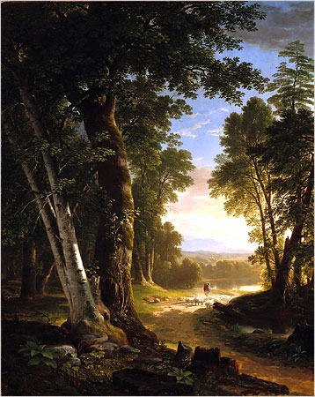  Asher B. Durand, American, 1796 – 1886 “The Beeches,” 1845, oil on canvas | 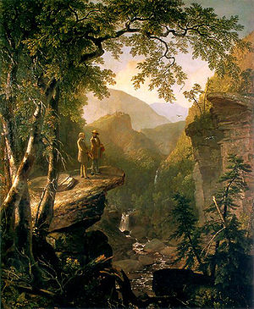  Asher B. Durand, American, 1796 – 1886 “Kindred Spirits,” 1849, oil on canvas
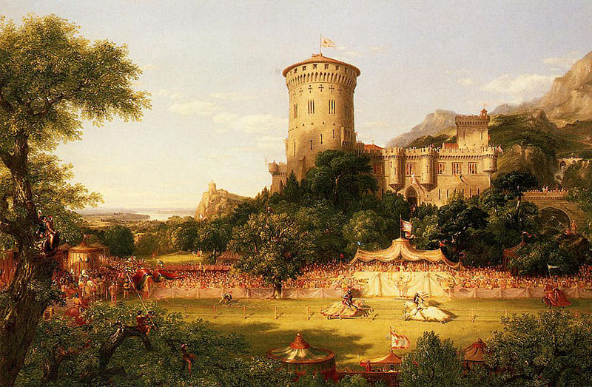  Thomas Cole, English (Naturalized American), 1801 – 1848 “The Past” (1838), oil on canvas | 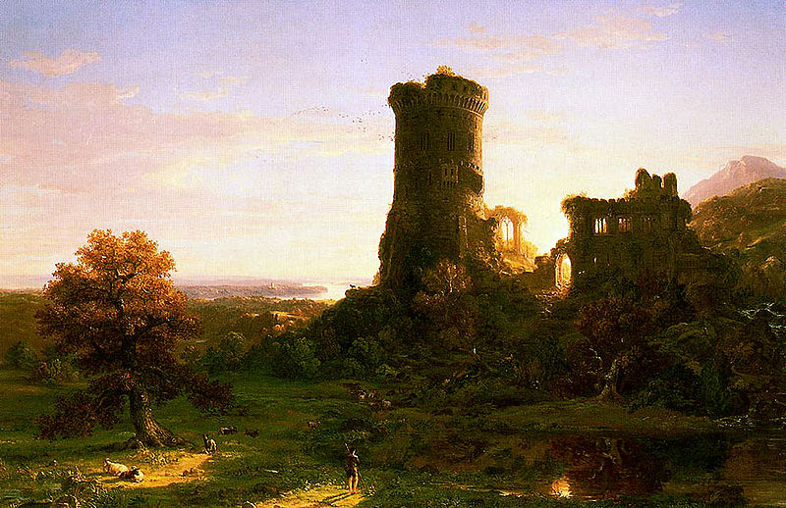  Thomas Cole, English (Naturalized American), 1801 – 1848 “The Present” (1838), oil on canvas

