- GROUP PODCAST – Setup, Recording, & Sharing: Group members must all contribute to one eight-to-ten-minute-long podcast, which will generate an embed code that the group leader will share with me. To record your podcast, I recommend Clyp (https://clyp.it/).
- SETUP: The group leader should create an account using his/her email. Recording the podcast is fairly easy and intuitive from that point. Prior to recording the podcast, each group member is expected to have an outline or notes of some sort shared with the teacher in a manner discussed in class. Consider completing a brief test recording so that everyone can hear how they sound and so that you may sit close enough to the device’s mic to ensure a successful recording.
- RECORDING: The group leader will moderate the podcast and will speak first, identifying him/herself. Each speaker in the group should announce his/her name before speaking, mention the focus of his or her assessment of style, mentions at least two pieces of evidence (quote or paraphrase) from research or choice book with proper introductory signal phrase followed by appropriate evaluative commentary during the course of your group’s conversation. While recording the group podcast, each group member is encouraged to consult his/her outline or notes from setup. Once all group members have spoken and have met minimum requirements, your group is encouraged to speak extemporaneously, in more conversational manner, to discuss the style of your choice novel.
- SHARING, ONCE YOU’VE RECORDED: Hopefully everyone in the group will be satisfied by the group’s recording. Because this conversation has a lot of moving pieces, mistakes & missteps may happen, but as long as the major elements are in place, there should be no reason for a second take. The podcast is a conversation, so people may stumble over words. This isn’t a problem as long as all speakers are audible and required elements are met. The group leader copy the embed code from Clyp and email it to me to post on our AP course website.

- HANDOUT – Textual Evaluation of Style & Purpose: Each student should contribute to a unified group handout that matches with the observations that each student made during the group podcast discussion, and the handout the group submits should amplify and support the ideas presented during the podcast. Each student should contribute approximately 250-350 words of text. Layout of text should blend with images in a manner that is aesthetically pleasing. The back of this document is meant to offer some very basic suggestions for layout, and it has 312 words of text. Do not feel constrained by these design suggestions. Content & accuracy is a big part of both the how your grade is calculated, so you should aim to make the appraisal and presentation of evidence both concise & precise.
Images: 8-10 Images should appear on the group’s handout. Each student in the group is encouraged to include a couple of images, but no handout should have more than 10 images. Ideally, images should support the observations that students make about the writer’s style. The layout and selection of images is up to each student, but each student should attribute the source with a caption that indicates, Borrowed from The Source Name. Images should be high quality and should offer a substantive addition to the group’s handout.

- WORKS CITED: Sources, including each student’s choice book, should be listed in correct MLA format on your works cited section of your handout. This step is very important when you consult outside sources to help you navigate your writer’s style. Each student should consult at least one book review from a reputable source is necessary to exceed expectations. Only one Works Cited for the group is needed.

- LINKS & EMAIL: Your group leader will share (via email) the podcast embed code with me (noting each group member’s name) in the subject line, and the group leader will attach the group’s handout + works cited (as a single, unified document) to the email and submit a printed copy to me on the specified due date. The idea is that I should be able to listen to your podcast and look at your group’s handout.
DUE DATE
Choice Book Content – Student One
When adding text in a handout, I find it easier to place text in compartments. It helps the reader to navigate the text more easily. You can do this in Word or Google Docs by adding a table. It is also easy to determine how much you’ve contributed to your document by highlighting the text and looking down at the bottom of the page. When I stop and do that with this sentence, I see that I have 80 words. |  | Borrowed from Pinterest
Choice Book Content – Continued
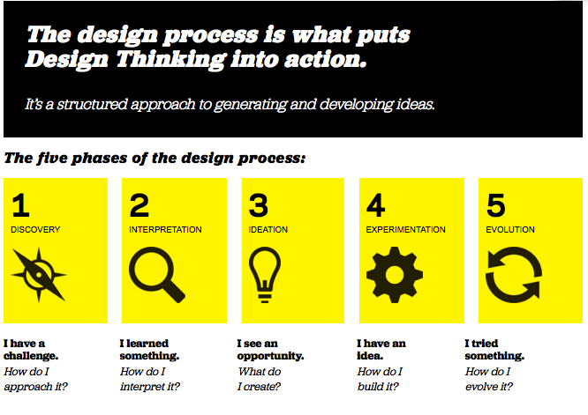  Borrowed from http://blog.roadtripnation.org |  | One of the things you’ll notice, is that I’ve staggered my text and images. This lends a certain amount of balance to my handout sample. You may also note that I’m varying my font size in meaningful but consistent ways to help the reader navigate the text more meaningfully. The images are also captioned. In so doing, it is not necessary to note the sources of the images on your Works Cited. Obviously, the design challenge your group will encounter is that you all may have individual design desires that are not met. Don’t despair. This group activity is meant to serve an introduction to the challenges of design and style that you’ll be asked to solve as an individual later in the semester. This paragraph has 129 words.
Choice Book Content – Another Important Idea…
The final point I will make relates to the relatively generic quality of this handout sample. I don’t wish to be prescriptive about design with this document but to inspire your group’s design choices. You have more text and images to contribute, as well as in-text citations and a works cited. At a glance you can see that this handout will be about one page per student, not including the group’s Works Cited page. I’ve indicated the amount of text in each section so that you can have an idea about what to expect. For instance, this block of text has 103 words. |  | 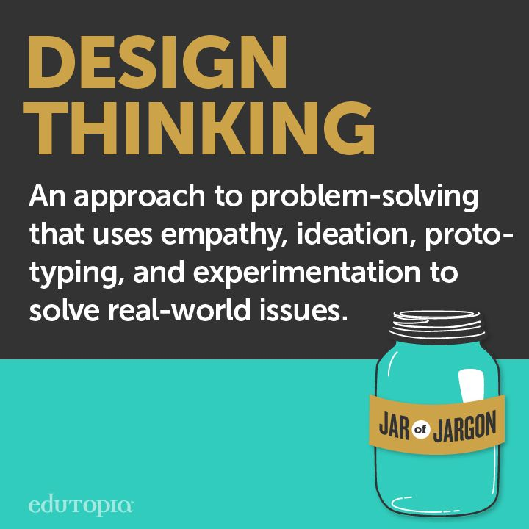  Borrowed from Edutopia

