What is style? How is style evaluated? Phillips
In fashion, photography, art, or architecture style isn’t so much WHAT someone selects, but HOW a person arranges the elements to create a desired effect. Consider and discuss the choices evident in following images and the desired effect of the choices. Writers tend to make similar choices…
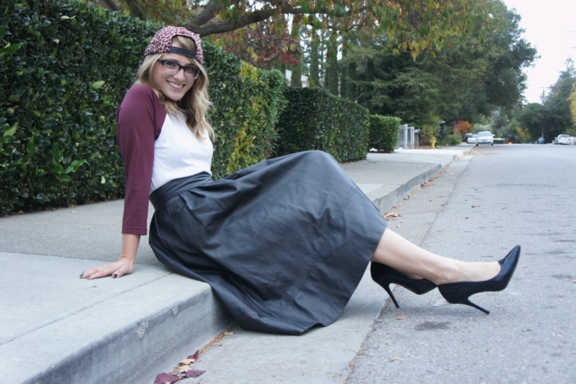  From “The Ohio Transplant” | 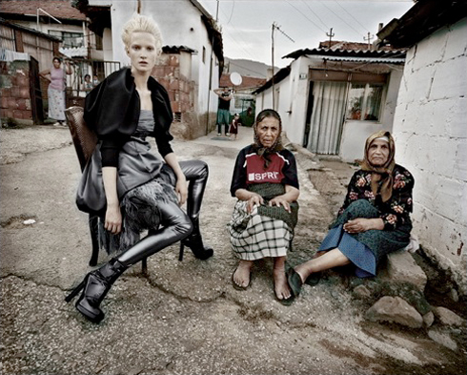  From Jean-François Campos
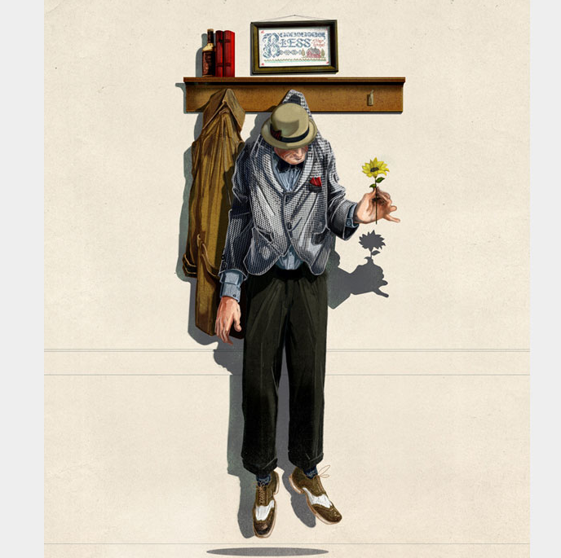  “The Nice Guy Complex,” Jonathan Bartlett | 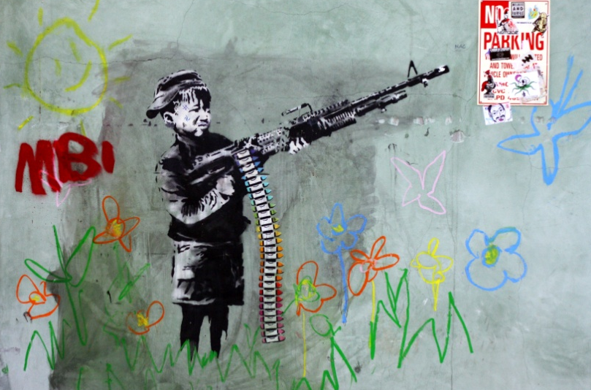  “Crayon Boy (Gun)” Banksy
Evaluation of a Written or Spoken Text – Style & Purpose
Consider the following reading and look for patterns (perhaps repetition or parallelism) in word choice (diction) and sentence structure (syntax). These are important stylistic elements in writing that shape tone (the attitude) of the writing and the mood (the feel or emotion) of the text. With writing, as with other mediums where style is important, we must also consider the context and audience. Annotate the text below with the above considerations in mind.
Lou Gehrig's Farewell Address
"Fans, for the past two weeks you have been reading about the bad break I got. Yet today I consider myself the luckiest man on the face of this earth. I have been in ballparks for seventeen years and have never received anything but kindness and encouragement from you fans.
"Look at these grand men. Which of you wouldn't consider it the highlight of his career just to associate with them for even one day? Sure, I'm lucky. Who wouldn't consider it an honor to have known Jacob Ruppert? Also, the builder of baseball's greatest empire, Ed Barrow? To have spent six years with that wonderful little fellow, Miller Huggins? Then to have spent the next nine years with that outstanding leader, that smart student of psychology, the best manager in baseball today, Joe McCarthy? Sure, I'm lucky.
"When the New York Giants, a team you would give your right arm to beat, and vice versa, sends you a gift - that's something. When everybody down to the groundskeepers and those boys in white coats remember you with trophies - that's something. When you have a wonderful mother-in-law who takes sides with you in squabbles with her own daughter - that's something. When you have a father and a mother who work all their lives so you can have an education and build your body - it's a blessing. When you have a wife who has been a tower of strength and shown more courage than you dreamed existed - that's the finest I know.
"So I close in saying that I might have been given a bad break, but I've got an awful lot to live for."
Two-Column Notes – A Thesis Building Exercise
Choices made by/devices used by the speaker/writer? | Purpose or impact of the choices/devices?
THESIS = TAG (Title, Author, Genre) + Choice(s)/Device(s) + Purpose/Effect

